Secco OS2-75 Bifold Doors Performance Specifications
The French Steel Company
Architectural Grade Steel Doors
Compliant with EN 14351-1:2016 and NFRC Standards
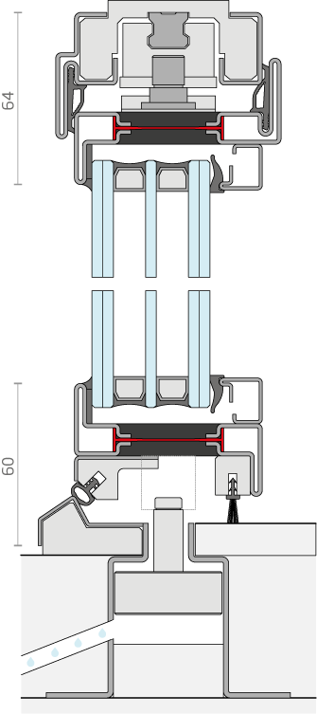
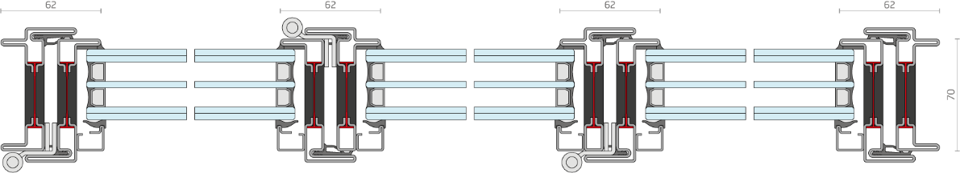

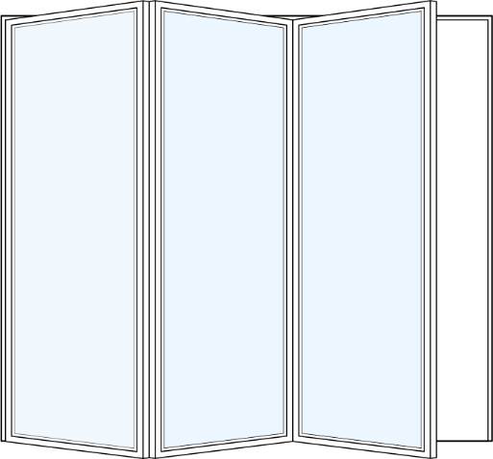

The French Steel Company’s OS2-75 Bifold Doors are designed for high-performance applications, achieving maximum certified performance under EN 14351-1:2016. The following outlines the technical performance ratings for air permeability, water tightness, wind load resistance, and thermal transmittance, with testing conducted per EN and NFRC protocols.

1. Air Permeability Performance
Test Standard: EN 14351-1:2016, EN 12207.
Description: The French Steel Company’s OS2-75 Bifold Doors are tested for air permeability at a differential pressure of 75 Pa (1.57 psf). The maximum certified performance achieves Class 4, corresponding to a maximum air leakage of 0.06 cfm/ft², suitable for Commercial Windows (CW) class. The OS2-75 employs precision-engineered seals and multi-point locking systems to achieve compliance.
Performance Data:
Product Class | Max Air Leakage (cfm/ft² at 75 Pa / 1.57 psf) | EN 12207 Class
R (Residential) | 0.30 | Class 3 (moderate)
LC (Light Commercial) | 0.30 | Class 3 (moderate)
CW (Commercial Windows) | 0.06 | Class 4 (high)
OS2-75 Rating: ≤ 0.06 cfm/ft² at 1.57 psf, achieving EN 12207 Class 4 (high). Tested with The French Steel Company’s proprietary weatherstripping system.
2. Water Tightness Performance
Test Standard: EN 14351-1:2016, EN 12208.
Description: The French Steel Company’s OS2-75 Bifold Doors are evaluated for water tightness under static conditions. The maximum certified performance achieves Class 5A, with no uncontrolled water leakage at 3.1 psf (150 Pa) static pressure for 15 minutes, suitable for exposed applications. The OS2-75 integrates advanced gasketry and drainage systems to ensure performance.
Performance Data:
Product Class | Test Pressure (psf / Pa) | Duration | EN 12208 Class
R (Residential) | 0 psf (0 Pa) static | 15 min | Class 1A (low)
LC (Light Commercial) | 2.1 psf (100 Pa) static | 15 min | Class 3A (moderate)
CW (Commercial Windows) | 4.2 psf (200 Pa) static | 15 min | Class 7A (high)
OS2-75 Rating: No penetration at 3.1 psf (150 Pa) static, achieving EN 12208 Class 5A compliance. The French Steel Company’s multi-point locking and continuous perimeter seals ensure robust water tightness for exposed installations.
3. Wind Load Resistance
Test Standard: EN 14351-1:2016, EN 12210.
Description: The OS2-75 Bifold Doors are tested for structural integrity under uniform load per EN 12210. The French Steel Company’s steel frame construction achieves Class C3, with a minimum design pressure of 25.1 psf (1200 Pa). Deflection is limited to L/175 of span. Additional operational testing confirms hardware reliability.
Performance Data:
Product Class | Minimum Design Pressure (psf / Pa) | EN 12210 Class
R (Residential) | 8.3 psf (400 Pa) | Class C1
LC (Light Commercial) | 16.7 psf (800 Pa) | Class C2
CW (Commercial Windows) | 25.1 psf (1200 Pa) | Class C3–C4
AW (Architectural Windows) | ≥33.4 psf (1600 Pa) | Class C5 or higher
OS2-75 Rating: 25.1 psf (1200 Pa) positive/negative load, achieving EN 12210 Class C3. The French Steel Company’s reinforced hinges and steel frame support applications in moderate-wind zones, with custom testing available for higher classes.
4. Thermal Transmittance Performance
Test Standards: EN 14351-1:2016, EN 12567-1; NFRC 100-2020.
Description: The French Steel Company’s OS2-75 Bifold Doors achieve exceptional thermal performance through advanced glazing and frame technologies. The U-value is measured per EN 12567-1, with whole-product performance certified at 1.2 W/m²·K (0.21 Btu/h·ft²·°F), suitable for energy-efficient designs in cold climates, including ENERGY STAR v7.0 Northern Zone (U-factor ≤ 0.22).
Performance Data:
NFRC U-Factor (Btu/h·ft²·°F) | EN U-Value (W/m²·K) | Typical Fenestration Features
0.30 | 1.70 | Standard double-glazed, low-emissivity (low-E) coating, air-filled
0.20 | 1.14 | High-performance double-glazed, low-E, argon fill, warm-edge spacers
0.18 | 1.02 | Triple-glazed or advanced double-glazed, low-E, argon/krypton fill, thermally broken frame
0.15 | 0.85 | Triple-glazed, advanced low-E, krypton fill, insulated frame with thermal breaks
OS2-75 Rating: U-value of 1.2 W/m²·K (0.21 Btu/h·ft²·°F), achieved with:
- High-performance double-glazed units featuring low-E coatings (e = 0.05–0.10), argon gas fill, and warm-edge spacers (thermal conductivity < 0.1 W/m·K).
- The French Steel Company’s thermally broken steel frame with polyurethane thermal breaks (R ≥ 2.5 h·ft²·°F/Btu).
- Certified per EN 12567-1 and NFRC 100-2020, with center-of-glass U-factor ≤ 0.14 Btu/h·ft²·°F and whole-product SHGC (Solar Heat Gain Coefficient) ≤ 0.25 for optimal energy performance.
- Meets ENERGY STAR v7.0 Northern Zone requirements (U-factor ≤ 0.22 Btu/h·ft²·°F) and is suitable for IECC 2021 Climate Zones 5–8 (max U-factor 0.30–0.27 Btu/h·ft²·°F).
Notes:
- All ratings are based on standard installation per The French Steel Company’s guidelines and industry recommendations.
- Custom configurations (e.g., oversized units, specialty hardware) may require project-specific testing.
- Contact The French Steel Company for IGCC/LEED compliance documentation, thermal simulation reports, or additional NFRC certifications.
- The OS2-75’s advanced thermal performance supports sustainable building certifications, including LEED v4.1 and net-zero energy goals.

