Secco OS2-75 Outswing Doors Performance Specifications
The French Steel Company
Architectural Grade Steel Doors
Compliant with AAMA/WDMA/CSA 101/I.S.2/A440 and NFRC Standards
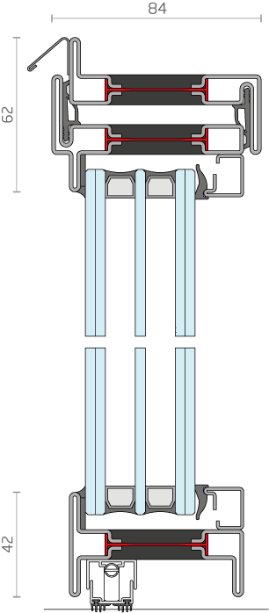
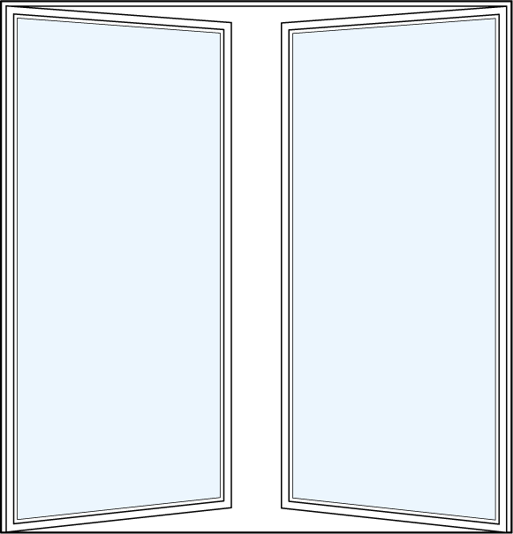

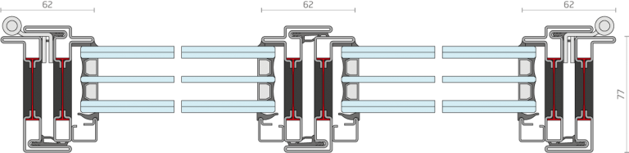

The French Steel Company’s OS2-75 Outswing Doors are designed for high-performance applications, achieving Grade CB or EB under AAMA/WDMA/CSA 101/I.S.2/A440. The following outlines the technical performance ratings for air leakage, water resistance, wind load, and thermal transmittance, with testing conducted per ASTM and NFRC protocols.

1. Air Leakage Performance
Test Standard: AAMA/WDMA/CSA 101/I.S.2/A440, Section 5.1 (ASTM E283-04).
Description: The French Steel Company’s OS2-75 doors are tested for air infiltration at a differential pressure of 1.57 psf (75 Pa). The maximum allowable air leakage is 0.3 cfm/ft² for Residential (R) and Light Commercial (LC) classes, with stricter limits for Commercial Windows (CW). The OS2-75 employs precision-engineered seals and multi-point locking systems to achieve compliance.
Performance Data:
Product Class | Max Air Leakage (cfm/ft² at 75 Pa / 1.57 psf) | Equivalent EN 12207 Class
R (Residential) | 0.30 | Class 3 (moderate)
LC (Light Commercial) | 0.30 | Class 3 (moderate)
CW (Commercial Windows) | 0.06 | Class 4 (high)

OS2-75 Rating: ≤ 0.3 cfm/ft² at 1.57 psf, meeting R and LC requirements. Optional high-performance seals allow CW-class compliance (≤ 0.06 cfm/ft²). Tested with The French Steel Company’s proprietary weatherstripping system.

2. Water Resistance Performance
Test Standard: AAMA/WDMA/CSA 101/I.S.2/A440, Section 5.2 (ASTM E331-00/E547-00).
Description: The French Steel Company’s OS2-75 is evaluated for water penetration resistance under static (ASTM E331) and cyclic dynamic (ASTM E547) conditions. The CW class requires no uncontrolled water leakage at 8.0 psf (384 Pa) static or 5.0 psf (240 Pa) dynamic pressure for 15 minutes. The OS2-75 integrates advanced gasketry and drainage systems to ensure performance.
Performance Data:
Product Class | Test Pressure (psf / Pa) | Duration | Equivalent EN 12208 Class
R (Residential) | 2.5 psf (120 Pa) static | 15 min | Class 7A (low)
LC (Light Commercial) | 4.0 psf (192 Pa) static | 15 min | Class 8A (moderate)
CW (Commercial Windows) | 8.0 psf (384 Pa) static or 5.0 psf (240 Pa) dynamic | 15 min | Class 9A (high)

OS2-75 Rating: No penetration at 8.0 psf (384 Pa) static, achieving CW class compliance. The French Steel Company’s multi-point locking and continuous perimeter seals ensure robust water tightness.

3. Wind Load Resistance
Test Standard: AAMA/WDMA/CSA 101/I.S.2/A440, Section 5.3 (ASTM E330-14).
Description: The OS2-75 is tested for structural integrity under uniform load (ASTM E330) at positive and negative pressures. The French Steel Company’s steel frame construction ensures a minimum design pressure of 30 psf (1440 Pa) for CW class, with custom configurations supporting up to 40 psf (1920 Pa) for Architectural Windows (AW). Deflection is limited to L/175 of span. Additional operational testing at 8–10 psf (384–480 Pa) confirms hardware reliability.

Performance Data:
Product Class | Minimum Design Pressure (psf / Pa) | Equivalent EN 12210 Class
R (Residential) | 15 psf (720 Pa) | Class C2 or higher
LC (Light Commercial) | 25 psf (1200 Pa) | Class C3–C4
CW (Commercial Windows) | 30 psf (1440 Pa) | Class C4–C5
AW (Architectural Windows) | ≥40 psf (1920 Pa) | Class C5 or higher

OS2-75 Rating: 30 psf (1440 Pa) positive/negative load, meeting CW class requirements. The French Steel Company’s reinforced hinges and steel frame support high-wind zone applications, with custom testing available to 40 psf.

4. Thermal Transmittance Performance
Test Standards: AAMA/WDMA/CSA 101/I.S.2/A440, Section 5.4 (ASTM C1363-11); NFRC 100-2020.
Description: The French Steel Company’s OS2-75 achieves exceptional thermal performance through advanced glazing and frame technologies. The U-factor is measured per NFRC 100, with whole-product performance certified for energy efficiency. The OS2-75 targets a U-factor of 0.18 Btu/h·ft²·°F (1.02 W/m²·K), suitable for cold climates and energy-efficient designs, including ENERGY STAR v7.0 Northern Zone (U-factor ≤ 0.22) and near-Passive House standards (≤ 0.20).
Performance Data:
NFRC U-Factor (Btu/h·ft²·°F) | Equivalent EN U-Value (W/m²·K) | Typical Fenestration Features
0.30 | 1.70 | Standard double-glazed, low-emissivity (low-E) coating, air-filled
0.20 | 1.14 | High-performance double-glazed, low-E, argon fill, warm-edge spacers
0.18 | 1.02 | Triple-glazed or advanced double-glazed, low-E, argon/krypton fill, thermally broken frame
0.15 | 0.85 | Triple-glazed, advanced low-E, krypton fill, insulated frame with thermal breaks
OS2-75 Rating: U-factor of 0.18 Btu/h·ft²·°F (1.02 W/m²·K), achieved with:
- Triple-glazed units featuring dual low-E coatings (e = 0.05–0.10), argon or krypton gas fill, and warm-edge spacers (thermal conductivity < 0.1 W/m·K).
- The French Steel Company’s thermally broken steel frame with polyurethane thermal breaks (R ≥ 2.5 h·ft²·°F/Btu).
- Certified per NFRC 100-2020, with center-of-glass U-factor ≤ 0.12 Btu/h·ft²·°F and whole-product SHGC (Solar Heat Gain Coefficient) ≤ 0.25 for optimal energy performance.
- Exceeds ENERGY STAR v7.0 Northern Zone requirements (U-factor ≤ 0.22 Btu/h·ft²·°F) and approaches Passive House Institute standards (U-factor ≤ 0.14–0.20).
- Suitable for IECC 2021 Climate Zones 5–8 (max U-factor 0.30–0.27 Btu/h·ft²·°F).
Notes:
- All ratings are based on standard installation per The French Steel Company’s guidelines and WDMA recommendations.
- Custom configurations (e.g., oversized units, specialty hardware) may require project-specific testing.
- Contact The French Steel Company for IGCC/LEED compliance documentation, thermal simulation reports, or additional NFRC certifications.
- The OS2-75’s advanced thermal performance supports sustainable building certifications, including LEED v4.1 and net-zero energy goals.
